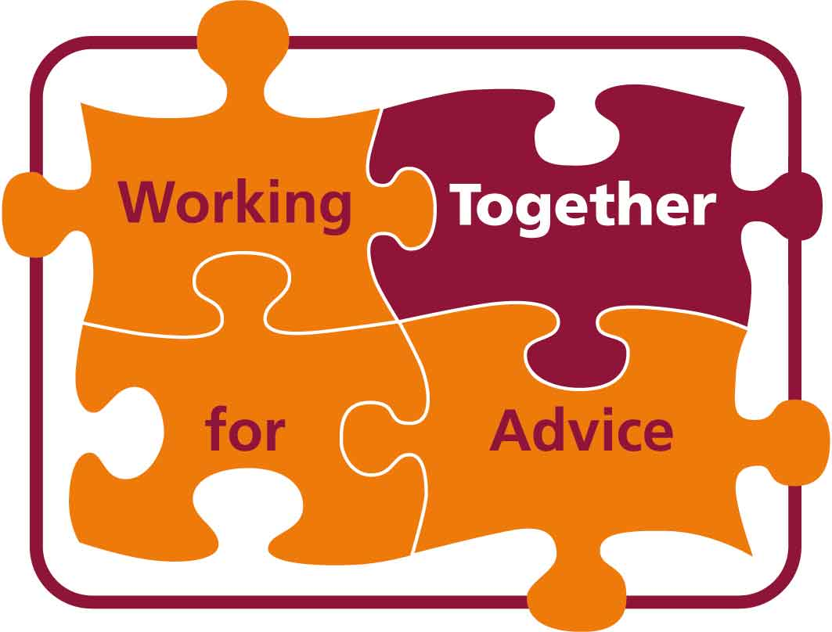
Discrimination Advice Resource List
For advisers working on discrimination issues
Developed by the Developing Discrimination Advice Workstream
Revised July 2010

We have compiled this list of useful organisations and websites to help discrimination advisers access a range of resources, including handbooks, specialist support, telephone helplines and training on discrimination advice issues. Many of the resources are free. We have indicated where there is a charge for them. Some of the resources are aimed at specialist discrimination advisers and some are aimed at the public, but we have included them because they contain information that may be useful to advisers. For more information on the range of services and support offered by each organisation visit the relevant website.

Please note that we consider it to be essential that all advisers involved in providing discrimination advice have access to a comprehensive guide to the law, either in the form of an up to date handbook or an online reference.

Contents
All areas of discrimination 1
Education 4
Employment 4
Housing 5
Human Rights 6
Public Functions 6
Specific characteristics/ equality groups 6

All areas of discrimination

Advicenow
Advicenow has a range of resources which explain what discrimination is and the action people can take to sort out discrimination problems. You can also search the Advicenow website for links to other discrimination-related information.
www.advicenow.org.uk/is-that-discrimination

Bar Pro Bono Group
The Bar Pro Bono Unit is a charity which helps to find pro bono (free) legal assistance from volunteer barristers. It can assist with assist with:
- advice, representation and help at mediation
- cases in all legal areas (including discrimination)
- cases where proceedings have not yet been started
- cases in all tribunals and courts in England and Wales.
Pro bono assistance is only available to those who cannot afford to pay and who cannot obtain public funding (Legal Aid).
www.barprobono.org.uk

Citizens Advice
The Adviceguide website is the main public service information service of Citizens Advice. It gives general guidance on rights, and includes information on discrimination and downloadable fact sheets.
www.adviceguide.org.uk

Citizens Advice Specialist Support
Citizens Advice Specialist Support has expertise and provides consultancy in the fields of employment and discrimination, housing, money advice and welfare benefits for all Citizens Bureaux, and in employment to Legal Services Commission (LSC) quality-marked advice agencies. They also provide a wide programme of Continual Professional Development (CPD) accredited specialist courses in employment and discrimination. For further information email specialistsupport@citizensadvice.org.uk.

Discrimination Law Association (DLA)
DLA is a membership organisation which brings together a broad range of people and organisations interested in preventing and opposing discrimination. Its activities include responding to government consultations, practitioner group meetings, briefings, email updates, conferences and seminars. Annual membership for small voluntary groups costs around £60.
www.discriminationlaw.org.uk

Equality and Diversity Forum (EDF)
A network of national organisations committed to equal opportunities, social justice, good community relations, respect for human rights and an end to discrimination. They produce a free electronic newsletter which contains information about new equality and human rights developments, policy and publications, as well as details of forthcoming events and job vacancies.
www.edf.org.uk

Equality and Human Rights Commission (EHRC)
The EHRC’s website has an advice and guidance section with useful information and guidance on challenging discrimination.
www.equalityhumanrights.com
The EHRC’s Legal Directorate runs a specialist advice line for advisers, which can advise about the implications of the law, completing legal procedures, framing legal arguments and the potential for Commission funding.
Telephone lines are open Tuesday – Thursday, 9.30am – 12.30pm
Sex, equal pay or sexual orientation discrimination:  0161 829 8403
Disability or age discrimination:  0161 829 8303
Race or religion or belief discrimination:  020 31170302
Email: adviserline@equalityhumanrights.com

Equalities Mediation Service, Mediation Works
The Equalities Mediation Service is an independent and impartial service, funded by the EHRC, for resolving disputes about discrimination in the provision of goods and services and in education and employment. Mediation offers an alternative to often lengthy legal processes. The service aims to assist people to reach their own solutions to complaints of discrimination, by mediating between both parties involved in a disagreement. Nearly 80% of cases referred to the service reach full agreement. The service covers cases of discrimination on the characteristics of age, disability, gender, race, religion or belief and sexual orientation. The EHRC helpline or specialist advice line can refer cases to the Equalities Mediation Service or you can contact them directly for information.
http://www.adrnow.org.uk/go/SubPage_38.html
http://mediation-works.co.uk/equalities

Equal Opportunities Review
The journal focussed on equality, diversity and discrimination law and practice from Michael Rubenstein. An annual subscription for monthly issues of the journal, access to EOR Online and a copy of Discrimination: A Guide to the Relevant Case Law costs around £365.
www.eordirect.co.uk

Government Equalities Office (GEO)
GEO has responsibility within Government for equality strategy and legislation. It is responsible for developing the Equality Act 2010 and updates on the implementation of the Act are available on the GEO website.
www.equalities.gov.uk

LawWorks
LawWorks is a charity which aims to provide free legal help to individuals and community groups who cannot afford to pay for it and who are unable to access legal aid. LawWorks offers a wide variety of free services to advice agencies throughout England and Wales. These include:
- Helping to set up a free, after hours, legal advice Clinic
- Providing a referral route for your clients to receive free legal assistance including representation and mediation
- Access to a system which can provide answers to straightforward legal questions
- A bank of legally qualified volunteers, wanting to do pro bono work whilst seeking employment
www.lawworks.org.uk

Legal Action Group
Legal Action Group provides training and publications on a wide range of legal issues, including discrimination. They produce a Discrimination Law Handbook (costs around £55), an Employment Law Handbook and run a Discrimination Law Update training course.
www.lag.org.uk

Office of Public Sector Information
Anti-discrimination legislation can be downloaded from this government website.
www.opsi.gov.uk
The Equality Act 2010 and explanatory notes can be downloaded from www.opsi.gov.uk/acts/acts2010/ukpga_20100015_en_1

Education

Advisory Centre for Education (ACE)
The Advisory Centre for Education (ACE) is a national charity that provides advice and information to parents and carers on a wide range of school based issues including exclusion, admissions, special education needs, bullying and attendance.
www.ace-ed.org.uk

Children’s Legal Centre
The Children’s Legal Centre runs a national education helpline through Community Legal Advice.
www.childrenslegalcentre.com

Independent Panel for Special Education Advice (IPSEA)
IPSEA is a registered charity offering free and independent advice to parents of children with special educational needs in England and Wales.
www.ipsea.org.uk

Skill: National Bureau for Students with Disabilities
Skill promotes opportunities for disabled people in learning and employment. It has a UK-wide service providing information and advice to disabled students and people calling on their behalf, on access to education after age 16, training at work, entry to employment and volunteering.
www.skill.org.uk

Employment

Acas
Acas stands for Advisory, Conciliation and Arbitration Service. It aims to improve employment relations. Employers and Employees can get free advice from their website or telephone helpline.
www.acas.org.uk

Central London Law Centre
Tamara Lewis has written a number of resources for employment discrimination advisers. The following 3 publications can be downloaded free from the Central London Law Centre’s website:
- Identifying employment cases: checklists for diagnosis and interviews
- Identifying discrimination in employment – a diagnostic and referral guide
- The Claimant's Companion: a client's guide to employment tribunal cases
www.londonlawcentre.org.uk/publications.html

Daniel Barnett
A website where you can sign up for free email updates on latest decisions in employment case law and legislative changes.
www.danielbarnett.co.uk

Emplaw
An online resource provided by the Employment Lawyers Association available by subscription providing up-to-date legislative and case law developments on employment.
www.emplaw.co.uk

Employment Lawyers Association
A national membership association of over 5,000 lawyers who specialise in employment law. They provide training, commentary, analysis and up-dates on employment law developments.
www.elaweb.org.uk

IDS Employment Law Brief
IDS Employment Law Brief is a fortnightly Brief and online service providing information and analysis on employment law cases and legislation. It costs in the region of £600 per year to subscribe.
www.incomesdata.co.uk/Catalogue/ProductDetails.aspx?recordid=3717&productid=181925

Tolley’s Discrimination in Employment Handbook
A handbook written by a team of barristers and solicitors, which provides in-depth coverage and practical advice. It costs £75.
http://www.lexisnexis.org.uk/employmentlaw/

Trade Union Congress (TUC)
Member Unions of the TUC represent over six and a half million working people. The TUC provide information, publications and training on employment discrimination issues.
www.tuc.org.uk
www.worksmart.org.uk is the TUC’s public facing website.

Housing

Housing Rights Information
The housing rights website has some information regarding discrimination in housing, mostly with regard to racial discrimination. The website can be searched with keywords.
housing-rights.info/index.html

Shelter
Shelter, the housing and homelessness charity, provide some training courses on housing discrimination issues, including a course on racial harassment and the Disability Equality Duty. They have an online guide to housing law which is available by subscription.
england.shelter.org.uk

Human Rights

The Aire Centre (Advice on Individual Rights in Europe)
Provides information and advice throughout Europe on international human rights law, including the rights of individuals under the provisions of European Community Law, and can give direct legal advice and assistance on a case by case basis to legal practitioners or advisers.
www.airecentre.org

British Institute of Human Rights (BIHR)
The British Institute of Human Rights provides a range of information and resources and develops and delivers training and consultancy around human rights issues. They have produced some useful human rights guides for disabled people, older people, people with mental health problems and refugees/ asylum seekers that are available to download from their website.
www.bihr.org.uk/resources/guides

Liberty
Liberty has a website which provides support to individuals and organisations in understanding and enforcing rights under the Human Rights Act 1998. They also have a dedicated human rights advice and information service for voluntary sector organisations, which can be accessed by phone, fax or online.
www.yourrights.org.uk

Ministry of Justice
A number of government guides to human rights can be downloaded from the Ministry of Justice website, including a guide to the Human Rights Act.
www.justice.gov.uk/guidance/humanrights.htm

Public Functions

Public Law Project
A national legal charity which aims to improve access to public law remedies for those whose access is restricted by poverty, discrimination or other similar barriers. They have resources on their website and offer training on public law.
www.publiclawproject.org.uk

Specific characteristics/ equality groups
Please note: The following list does not attempt to cover all protected characteristics or equality groups. It is just a selection of useful resources/ national organisations.

AgeUK
Previously Age Concern and Help the Aged. Have information on ageism in employment.
www.ageuk.org.uk/work-and-learning/discrimination-and-rights

Children’s Legal Centre
The Children’s Legal Centre provides legal advice, information and representation for children and young people.
www.childrenslegalcentre.com

Disability Law Service
The Disability Law Service provides advice, training and a national helpline on disability discrimination law. Its website has some useful factsheets to download.
www.dls.org.uk

Fawcett Society
Fawcett campaigns for equality between women and men in the UK on pay, pensions, poverty, justice and politics.
www.fawcettsociety.org.uk

Friends, Families and Travellers
An organisation which aims to end racism and discrimination against Gypsies and Travellers. Their website includes guides to the law, a database of Gypsy and Traveller organizations across the country and links to useful resources. Their advice and information unit runs a national helpline.
www.gypsy-traveller.org

Kalayaan – Justice for migrant domestic workers
Migrant domestic workers are people who have entered the UK legally with an employer on a domestic worker visa to work in a private household. Kalayaan is the only organisation in the UK providing support services specifically to migrant domestic workers. Domestic migrant workers are especially vulnerable to gender and race discrimination by their employers.
www.kalayaan.org.uk

Maternity Action
Provide information sheets on employment rights of pregnant women and new parents.
www.maternityaction.org.uk

RAD Legal Services (Royal Association for Deaf People)
RAD Legal Services is a dedicated legal service providing specialist, independent legal advice working for Deaf people (by which they mean deaf people whose first or preferred language is sign language). They provide legal advice and representation on discrimination issues.
www.radlegalservices.org.uk

Stonewall
The lesbian, gay and bisexual charity, which has information on their website about anti-discrimination rights in employment and in the provision goods and services.
www.stonewall.org.uk

Trans Equality Project, Press for Change
A dedicated telephone and email equalities and human rights legal help and advice service for all trans people. The project provides a service to all Trans people, those who work with them, and those who employ them or provide them with services.
transequality.co.uk

Working Families
Has a section on their website aimed at supporting parents through discrimination claims. It includes case studies of relevant legal precedents, key case steps and other resources. They run a freephone helpline for parents and carers.
www.workingfamilies.org.uk

Help us to improve this list
This list has been compiled by the Developing Discrimination Advice workstream of the Working Together for Advice project. It is a cross-network project funded by the Big Lottery Fund, running from 2008-2010. WTfA aims to build the infrastructure of the advice sector and involves the following advice networks:
- Advice Services Alliance
- AdviceUK
- Age UK
- Citizens Advice
- Law Centres Federation
- Youth Access
For more information about the project please go to www.asauk.org.uk.

If you have any comments on this list or are aware of other resources that are useful to discrimination advisers and which are not included please pass details on to Flora Williams at the Law Centres Federation at flora@lawcentres.org.uk or Jo Chimes at Citizens Advice at jo.chimes@citizensadvice.org.uk.

